**RESTURANT TABLE BOOKING SYSTEM**

SYNOPSIS

SUBMITTED IN PARTIAL FULFILLMENT OF THE REQUIREMENTS FOR

THE DEGREE OF

MASTER OF COMPUTER APPLICATIONS



DEPARTMENT OF MATHEMATICAL AND COMPUTATIONAL SCIENCES

**NATIONAL INSTITUTE OF TECHNOLOGY KARNATAKA**

SURATHKAL, MANGALORE-575025

MARCH, 2020

SUBMITTED BY SUBMITTED TO

DIVAS KUMAR (194CA024) MS USHA KIRAN

ANIKET KUMAR (194CA009)

2nd SEMESTER

**ABSTRACT**

Restaurant table booking system is a web application. The project consists a web application that can be used by customer to reserve the desired timing and table of the restaurant. The web-portal is being managed by the owner to check the booking and make the availability for the customer. the services that are provided in this web application is to reserve the table of restaurant, select the purpose of booking, no of peoples and meal type i.e. veg or non-veg. in the web application which has complete information about restaurant, its branches and menu.  
The main objective of this project is that save time. Now a day all are crazy about for food no matter how old or young. They want to eat at restaurant and enjoy our precious time with friends & family. But problem is that generally, we all go to restaurant during weekends and during festival time and at that time there is too much crowd in restaurant and we have to wait for table and after that food too. To overcome from this, we have a solution and that is we can pre-book our table & time of arriving in the restaurant.

**INTRODUCTION**

We propose to build a software project that can efficiently handle and manage various activities of a restaurant and all these activities will be happening under the supervision of the administrator. The businesses in restaurants are now growing constantly. At the same time, the need for managing its operations and tasks arises. The best way to optimize these activities is growing the business online as well. Today’s generation encourages high-tech services especially over the Internet. Hence the project is developed proficiently to help restaurant owners automate their business operations. This project serves the best way of maintaining customer’s information and caters their needs.

It is convenient self-service table booking system that can be embedded on any website. With the restaurant reservation system, customers can create a customized booking process. This booking can be seen by admin from his account and he may approve or disapprove the request. Customers will have to wait for a table until its free especially during peak hours and then the ordering staff will record customer orders. Having placed the order, the customer then have to wait near the counter until their order is ready to collect. In this scenario customers have to wait for a long hour and as we know that now a day all are quite busy so this Restaurant table booking system may be really helpful for them.

**OBJECTIVE**

The objective of the system is –

* To reduce the paperwork
* Reduced operational time
* Increased accuracy and reliability
* Fast process
* Increased operation efficiency
* Increased data security

**PROPOSED SYSTEM**

This system is a bunch of benefits from various point of views. As this online application enables the end users to registers to the system online, select the cake of their choice from the menu list and order cake online. Also, payment can be made through online or at the time of home delivery depending upon the customer’s choice and convenience. By tracking the customer’s order, it is easy to improve the cake delivery service.

**BLOCK DIAGRAM**

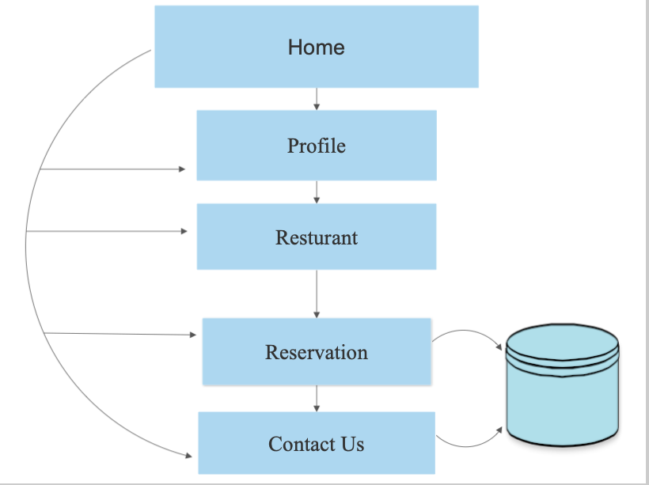

**TOOLS AND TECHNOLOGY**

**SOFTWARE REQUIREMENT**

**Front End**  : Html, CSS

**Language** : Php

**Platform** : Window 10 and above

**Database Technology** : MySQL

**HARDWARE REQUIREMENT**

**Processor** : Intel core i3 8th Gen above 2.0GHZ

**RAM** : 8GB

**Hard disk** : 1TB